SOP for Assessment of Carotid Stenosis by Ultrasound
Carotid stenosis is assessed using a combination of B-mode ultrasound and Doppler flow velocity measurements.
In general, stenosis ≥50% is primarily classified using Doppler velocity criteria, whereas stenosis of 30–49% is classified using NASCET measurements on B-mode imaging.
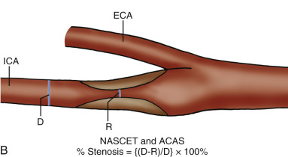
Stenosis severity is categorized as mild (30–49%), moderate (50–69%), or severe (70–99%).
For each category, the primary diagnostic criterion is highlighted; supporting criteria increase diagnostic confidence.
Abbreviations
PSV = peak systolic velocity
EDV = end-diastolic velocity
ICA = internal carotid artery
CCA = common carotid artery

Criteria:
30-49% stenosis
- Measured stenosis of 30-49% on B-mode ultrasound using NASCET criteria (primary criterion)¹
According to NASCET criteria, the degree of stenosis can be measured as the percentage reduction in luminal diameter at the site of maximal narrowing compared with the diameter of the normal distal internal carotid artery (see left figure 1).

On B-mode ultrasound, acquire a longitudinal image and a transverse image of the ICA at the site of maximal luminal narrowing. Measure the lumen diameter from inner wall to inner wall on longitudinal and transverse images . Subsequently, obtain a longitudinal and transverse image of the first distal ICA segment without visible plaque and measure the normal luminal diameter from inner wall to inner wall. In order not to overlook very echolucent plaques, apply colour or angio mode (figure 1).

Figure 2 shows another example of a stenosis measurement for 30-49% stenosis.

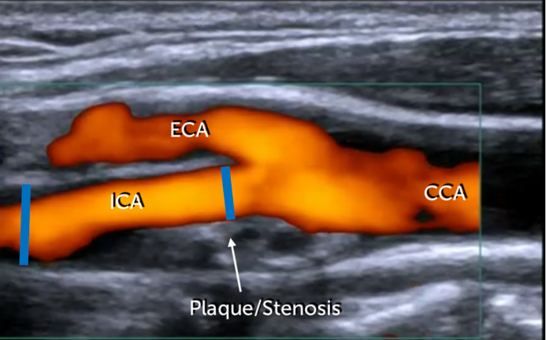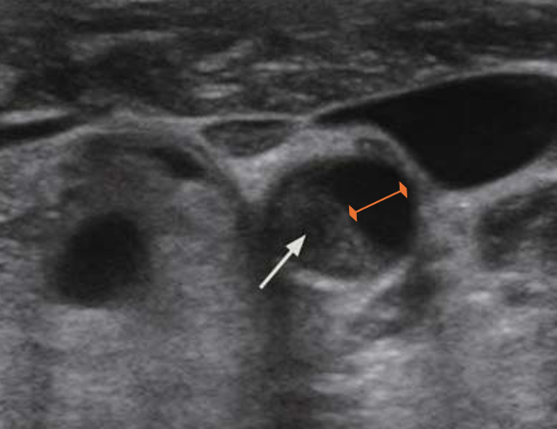Figure 1. Left: longitudinal B-mode image of the carotid bifurcation. The blue line at the origin of the internal carotid artery is the residual lumen, the blue line on the left is the lumen in the internal carotid artery just distal to the plaque. The degree of stenosis in this example is approximately 33% according to the NASCET criteria. Note that the degree of stenosis is just sufficient to classify for a mild stenosis despite the quite substantial plaque. Right: transverse image of the ICA at the site of maximum stenosis. The white arrow indicates the plaque. The
orange line indicates the stenosis measurement.

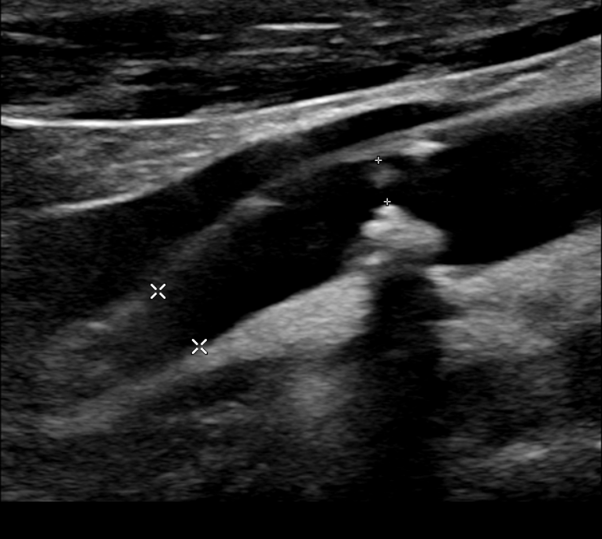
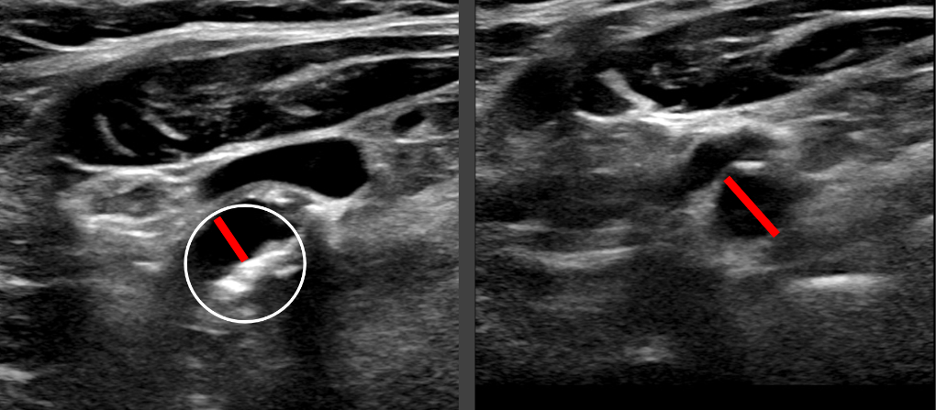

Figure 2. Left: longitudinal diameter measurements at the site of the smallest lumen and distally from the carotid stenosis. Right: cross-sectional diameter measurements at the same sites, yet in the cross-sectional view. Note that the white circle depicts the original lumen. In both cases, the degree of stenosis is approximately 30%, according to the NASCET criteria.

50-69% stenosis²
- ICA PSV is 125-230 cm/sec (primary criterion)
- Sonographically visible plaque with clear luminal narrowing (at least 50% of the local vessel diameter as estimated on B-mode imaging)
- ICA/CCA PSV ratio of 2-4
- ICA EDV of 40-100 cm/sec

≥70% stenosis (up to near occlusion)²
- ICA PSV is >230 cm/sec (primary criterion)
- Sonographically visible plaque with clear luminal narrowing (at least 70% of the local vessel diameter as estimated on B-mode imaging)
- ICA/CCA PSV ratio >4
- ICA EDV >100 cm/sec

Near occlusion (95-99% stenosis)
- Sonographically visible massive plaque formation
- PSV postsystolic <30 cm/s
- Variable velocity parameters within the stenosis (mostly rather normal or low)
- prestenotic diastolic flow in the CCA reduced

References:
1. Binder T. 11. Carotid Artery Stenosis Part 1: B mode and Color flow. https://123sonography.com/blog/11-carotid-artery-stenosis-part-1-b-mode-and-color-flow. 2021.
2. von Reutern GM, Goertler MW, Bornstein NM, Del Sette M, Evans DH, Hetzel A, Kaps M, Perren F, Razumovky A, von Reutern M, et al. Grading carotid stenosis using ultrasonic methods. Stroke. 2012;43:916-921. doi: 10.1161/STROKEAHA.111.636084

